

**Project Report**

**AI Automated Customer Service Chatbot**

**Group 3** - Natalie Nye; Himanshi Tanwar; Roshan Dubey; Shravanth Kulkarni; Colin Quinn

MIS-652-001

May 6th, 2023

Dr. Shah

**Table of Contents**

**Executive Summary** 3

Solving the Project Problem 3

Sprint Summary 4

Sprint 1 4

Sprint 2 4

Sprint 3 5

Sprint 4 5

Sprint 5 6

Sprint 6 6

Sprint 7 6

Tools and Techniques 7

Three Challenges 8

Three Lessons 9

**End of Sprint Reports** 10

Sprint Feedback Chart 11

**Conclusion** 11

**Figures and Images** 12-13

Kanban Board 12

Low-Level Chatbot Architecture 12

High-Level Chatbot Architecture 13

# Executive Summary

This document outlines our team’s approach to applying the agile processes using Scrum in delivering the architectural foundation for a functional automated chatbot to facilitate customer service operations for our customer, MRS BPO, a financial technology debt collection company. When utilizing an agile approach, the main components entail visualizing work, consistent and frequent communication, rules of engagement (when can start and when you are done), and continuous improvement. By using Scrum throughout our project, our team was able to develop an architecture for a customer service AI chatbot by using the agile processes. After encountering some challenges during the first few sprints, we significantly improved our process within the team which allowed for us to effectively outlay the architecture necessary for our customer to build an automated chatbot to assist with customer service. We learned how imperative it is to be transparent in our thoughts and ideas to help determine the best solution. We made customer value the focus of the project, making sure to be flexible and consistently open to change by taking feedback and applying it to continuously improve during each sprint. We used our sprint meetings to reflect on what we learned and to talk about ideas to make sure we stayed organized. Overall, our team rates the experience during this project as an overwhelming “5.” We felt that the project was a success in terms of learning the agile process, learning about AI chatbots, communicating with a real customer, and working on our presenting skills to effectively align business and IT. The most important lesson we learned from this project was to break the project down into small stories so we can manage the process easier and make sure to have deliverables to present to our customer at the end of each sprint.

**Our Approach**

## Solving the Project Problem

The main purpose for our chatbot was to assist with: management of peak contact times when MRS’s customers have to wait longer than anticipated, contact overflow conditions when agents are exceedingly busy, overnight and weekend hours when no agents are available, compliance needs to maintaining consistent with industry regulatory requirements, and consistency across customer communications and experience. Ultimately, our aim was directed towards removing the need for human action from the equation and automating MRS’s customer service operations.

When we first received the problem, it involved various complicated aspects which we needed to manage. We started by brainstorming ideas for features which we could incorporate into our architecture so that we could segment the necessary work into stages. We were not sure exactly what we needed to do, and we did not have a lot of experience in dealing with artificial intelligence based chatbots. Thus, we struggled when separating the project into smaller manageable stories based on the features we conceptualized. As a few people began with general research on the project, we had the scrum master and product owner organize the approach for creating the architecture while adhering to the agile process. This progressed into discussions about the technical requirements for the product as we considered what the best starting point would be after discussing with our customer and asking more deliberate and thorough questions. After discussing the product specifications further, we realized it would be impossible to generate the code necessary to create a chatbot in the timeframe we were allotted. We improvised, and modified our approach towards building the architecture necessary to create a framework and system of interconnected pieces which would ultimately allow for our chatbot to be created once approved by the customer. After further research, we were able to develop a better understanding of what would be feasible given our timeframe while also fulfilling the requirements specified by our customer. It was at this point where we gained the confidence and perspective for how we could effectively conceive the architecture for a chatbot that would solve MRS’s problem.

## Sprint Summary

### **Sprint 1**

At the start of the project, our team had little experience with Agile methodologies, and we lacked a clear idea of how to proceed with building a chatbot. We had few user stories and were unsure of how to incorporate AI while improving the bot's functionality to meet customer needs. To overcome these challenges, we spoke with our customer about how to more effectively approach the task at hand. Given the insights they were able to provide, we progressed by researching current companies who are actively utilizing AI among the business operations. The professor and Mr.Hrcsko were able to provide the necessary guidance for how to move forward with the project while adhering to agile processes. By the end of the first sprint, we had gathered additional feedback from the customer, and had a better understanding of how to design the bot with appropriate components. Through the process we realized that we could not create a chatbot in the time allotted and instead would have to just make an architecture with all the connecting elements that would be required.

During our first stand-up meeting, we discussed our progress and identified areas where we could improve. We gave further thought about how we could improve our user stories, and we updated the format of our Kanban board used to track our feature progress and prioritize tasks for the next sprint. While our progress was limited in the first sprint, we gained valuable insights and knowledge that we could use to improve our agile process and chatbot for future sprints. We made significant improvements on our collaboration and transparent communication within the team to more effectively deliver a valuable product to satisfy our customer.

### **Sprint 2**

During the second sprint, we used the feedback we received and began researching existing AI technologies and their functionalities. Based on this research, we broke down our user stories into smaller chunks and created a more structured plan for building the chatbot’s architecture. Each team member was assigned tasks based on their skills and expertise, and we worked collaboratively to accomplish our goals. To maintain alignment, we used a visual board with columns labeled; "To Do," "Doing," and "Done." This helped us keep track of our progress while ensuring we were properly adhering to the process of agile methodology. We also made sure to incorporate everyone's unique ideas and perspectives into the project. This is where our communication was very important, because people had unique ideas to incorporate and we were able to discuss and utilize all perspectives to create the best framework. Through the process we learned to trust each other and began to be open even if we disagreed with the ideas of the other group members. We were always respectful but willing to explain our individual ideas and how we thought those were a better solution. These discussions allowed us to work through all possible elements of the architecture and come up with more in depth architecture elements. Mr. Meyers, Professor, and Mr.Hrcsko visited us during the sprint, and provided valuable guidance and support for helping us maintain progress and adhere to the process. Overall, we were able to sort out the project much better than in the first sprint thanks to our improved understanding of the agile process, and our ability to work collaboratively as a team. We also had a standup meeting and noted what we had accomplished and the retrospective to discuss what should be done in the next sprint.

### **Sprint 3**

Despite the slow progress during the first and second sprint, we entered the third sprint with a clear plan of what features to include in our bot. We were determined to create a bot that would be unique while also meeting our customer's explicitly stated needs. However, we encountered some challenges when it came to incorporating the right plug-ins to ensure they provided the desired functionality within our architecture. To address these challenges, we consulted our customers for further feedback and guidance. He provided us with valuable insights on how to design and integrate the right components, and we incorporated great ideas from all team members to build the architecture. We divided the work so each member was working on different stories to allow us to get through as much work as possible in each sprint. Throughout the sprint, we continuously sought feedback from everyone to ensure we were on the right track. During each sprint, one of the team members also played the role of a scrum master who helped the entire team stay on the right track and follow agile principles. As a result, we made significant progress and were able to create good user stories by the end of the sprint. Overall, we were pleased with the progress we made in the third sprint and were confident that we were moving in the right direction to build a unique and effective chatbot.

### **Sprint 4**

During this sprint, we focused on implementing and building the structure of the chatbot. The research, feedback, ideas and stories we conducted was beneficial in plugging in the appropriate components to ensure that the architecture operates seamlessly in addressing customer queries. With multiple components to consider, we began making it easier by visually arranging them and creating a rough sketch on white paper. By the end of the sprint, we had a rough architecture and plan, which we showed to Mr.Meyer for feedback to ensure that it was perfect. However, we knew that there was still room for improvement, and we discussed potential enhancements during our standup meeting. During this sprint the scrum master made sure that we did not have too much WIP. At one point someone wanted to start another story but we had so many in the “Doing” category we would not be able to finish tasks during the sprint. To make sure we were able to get all of the stories completed during that sprint, we had people pair up to complete those stories.

### **Sprint 5**

Compared to previous sprints, we had a comprehensible idea of what we wanted to achieve in this stage of the project. We recreated the new architecture in a visual diagram in based on the feedback from the prior round. We began by working on the architecture, focusing on improving the customer and human interaction layer. We discovered an AI platform called Hugging Face that was unique in its ability to detect emotion, social intelligence, and history. After getting more feedback from Mr. Meyer we had to pivot again because it seemed that he did not like the new architecture as much as he liked the old architecture. We successfully integrated its top features into our bot architecture, and held a standup meeting to discuss improvements for the next sprint.

### **Sprint 6**

During this sprint, our group members developed a strong bond as we continued to work on implementing the remaining layers of our chatbot, particularly focusing on authentication for security purposes, accounts, and payment options such as credit card or debit card. We also made sure to provide an option for partial payments and an opt-out option for customers whose queries were not resolved. In case of any unresolved queries, the customers were able to raise tickets and contact our CRM for further assistance. We followed the instructions of Prof Shah, Mr. Hrcsko, and Mr. Meyer throughout all sprints and were able to design the chatbot architecture in a unique and comprehensive manner. We received approval from Mr. Meyer, and the standup meeting was productive, resulting in significant improvements. At this point in the project we really had great flow of the process and each worked on our individual stories to move them through the process and kanban board. By following agile methodologies, we were able to successfully accomplish the design.

### **Sprint 7**

In this sprint, we not only focused on building a rudimentary model of the bot but also on creating a final product report and presentation slides to showcase our work. We put a lot of effort into creating visually appealing and informative slides to effectively communicate the features and functionalities of our chatbot. For this part of the project we mobbed the two items to make sure that we were able to complete them during the sprint. We had half of our group finishing up the slides and the other people working on the product report. Some people were writing segments while other people worked on editing and reviewing. This made us feel like we were really embracing the process by having people review on uncompleted work. We practiced presenting multiple times to ensure that we were well-prepared and confident in our delivery. These presentations were a great opportunity for us to showcase all the hard work we put in over the previous sprints and to receive feedback from our peers, professors, and experts. We were able to present the unique features of our chatbot architecture, including the integration of Hugging Face AI for emotional and social intelligence, the layer for authentication and security, and the payment options for customers.

## Tools and Techniques

We used a variety of different tools on this project to implement Agile. One of the tools that we used for this project was a kanban board. We used the white board and sticky notes to create the kanban board. We did this to help visualize what everyone was doing. We started by creating the main features that we needed to include in the architecture and then we moved onto stories to break those features down into segments that we could complete in a two hour sprint. We made this more visual by color coding the sticky notes. The blue sticky notes were the features for the project and the pink sticky notes were the stories. We liked this method because we were able to move stories through the board at a faster rate to allow for continuously adding value for the customer and making sure we had something to show the customer at the end of each sprint. The kanban board also helped to create a physical element to the process as well because a person had to physically stand up and move a story from one section to another. This was especially helpful when moving items into the done category. We further used the visual by breaking down the done segment into each of our different sprints. This allowed us to see the progress of completing many more stories in the later sprints than in the first few.

We used the online tool "draw.io," which is free to use, to design and modify our chatbot architecture. As the tool was fully web-based, we collaborated on several versions of the architecture and exchanged ideas amongst ourselves to enhance it, taking into account Mr.Meyer’s feedback at the end of each sprint.

One of the tools we ended up using the most was "ChatGPT" because it is one of the most advanced chatbots in the world and can perform various language-related tasks such as answering questions, generating summaries, and providing recommendations. It became a benchmark for us while designing our chatbot. We were amazed by how precisely it was able to curate the best results for us from all over the internet and how well it was able to interpret questions in a human way.

We used WhatsApp to communicate when we were not together. Although most of the project we were in person and able to communicate face-to-face, there were times when we were not together. We mostly used that to ensure we were on the same page about homework assignments or informing the team of our arrival time. Since the class has ended we have continued to use the app for frequent communications to ensure we complete the final assignments before the due date. This helps with transparency as everyone is in the groupchat and can see everything that is going on.

One technique we used was the standup meetings. We used those to gauge where everyone was at and what we were doing. The first few that we did were not short enough. Even with standing we did not make it short enough. We started setting a timer to make sure that we did not go over and that we kept them straight to the point. It was helpful to see where people were at their tasks so when one item was getting close to being finished we had a better idea of where we could go next. For example, we wanted to make sure to finish the authentication step before starting two many other features because that was the gateway to anyone using the chatbot. After hearing that authentication was about to be finished we knew we could start on many other features in addition to the others we were working on at the time such as payment.

A second technique we used was the retrospective meetings. During those meetings we really reflected on what information we had learned from Mr.Meyerl and the feedback he had given us. During one of our conversations with Mr.Meyer he did not give us positive feedback to the new architecture structure we had created. We reflected on what that meant for us and how he seemed to be more positive on the old structure. That led us to consider a flow of information versus a network connection of all of the elements. After discussing this feedback we knew we needed to pivot to a different architecture. This reflective meeting allowed us to compare what we had before to the current model and see the changes we needed to make. These meetings allowed us to be flexible and pivot to a different idea when the customer feedback led us that way.

Another technique we used was pairing. We did this on a few features to try to get them completed quicker to be able to deliver value to Mr.Meyer. We did this also because we did not want to have too many things in WIP at the same time. As Johana talked about having too many things in WIP and how that will make it hard to find bottlenecks, we wanted to keep things moving to be able to move things to the done process and make sure we were working efficiently. We only swarmed at the very end of the project on the powerpoint and the product report but those we broke down into different stories that people individually worked on. During the product report we had many people doing different tasks. One person was formatting, while others writing and finally another editing and reviewing the paper.

## Three Challenges

There were various challenges our team needed to overcome throughout the length of the project completion process. One of which was the degree to which we decentralized control throughout the group to allow for transparent collaboration and beneficial discourse. As we progressed through each sprint, we often found ourselves getting involved with the discussion around features we weren’t supposed to be involved with.After more discussion we were able to work through those extra issues and refocus on the most important features. Another challenge we faced early in the process was figuring out how to create effective stories for our features. In turn, this made it difficult to figure out how to progress with effectively conceptualizing our features when fully incorporating them into our architecture. After getting feedback we learned how to make the stories smaller which allowed us to move through the process quicker. Lastly, another major challenge we encountered was effectively managing our time throughout each sprint. Early in the process we found ourselves spending more time than necessary on a single feature, which often took away the opportunity to focus necessary time on other features in order to meet the time frame within each sprint. While these challenges often caused inefficiency within our team, we made sure to be aware of where we could continuously improve. By the time we reached the end of the course’s duration we were all aware of where we needed to pivot focus to accommodate the issues we had been experiencing.

## Three Lessons

We learned myriad valuable lessons which can be carried on past this experience that can be used to improve the efficacy of our future project endeavors. Among them was the importance of self-discipline throughout all stages of the project. During our first three sprints there were various occasions where we all found our focus migrating from one feature to another, and away from what we had originally discussed was a priority. This was a factor we continuously identified during our retrospectives and made conscious efforts to improve upon while we progressed through the remainder of the project’s timeline. In the remainder of our sprints we each made significant progress on our ability to direct our focus, and maintain the self discipline to adhere to the plan we discussed for delivering the product to our customer within the designated time frame. By our seventh sprint we each knew when and how to incorporate ourselves individually so we were always providing value to the end deliverable.

Another lesson we took from this experience was the importance of transparent communication. This was vital as it allowed for each of us to offer valuable input from our personal experience and tap into our individual subject area strengths. It was helpful for creating a comfortable environment where each of us was able to be open and share with one another how we felt the process could be improved, or if we felt stressed or uncomfortable during any stage of the process. Through the lectures and the book, we learned to give feedback and not coach unless a person asked for help. Learning this allowed us to communicate more effectively and helped us to get more done.

Lastly, we all gained a deeper understanding for embracing the idea of change, and the detriments it could’ve caused if we hadn’t done so. When starting the process we each had minimal to no experience working with one another, and each of us had a different style of going about things that resonated with each of us. Additionally, due to all of us not having worked in an agile environment before, it required us to completely change the way we would normally work on such a project. When thinking about the final product, we each had a unique perspective for what we envisioned the products specifications should entail. This required the need for changing our perspectives to align with one another’s vision as well as with, most importantly, what our customer was specifically looking for. Without embracing the need for change we would’ve encountered lords of difficulty throughout all stages of the process. This course taught us a plethora of invaluable lessons beyond what we have mentioned above. Altogether, they will all be crucial for helping us make a deeper contribution on future projects.

# End of Sprint Reports

Constantly improving and being able to make changes is one of the most vital parts of agile, and we used end of sprint reports to evaluate our sprints. The End of Sprint Report served several purposes, including providing transparency into the team's progress, identifying potential roadblocks or areas for improvement, and facilitating communication between team members and stakeholders. Additionally, these reports helped the team to evaluate their performance against the sprint goal and to adjust their approach if necessary.

As depicted by the chart below, our team really struggled with user stories, sustainable pace and small releases in the first sprint; we were not able to practically implement the agile methodology and all of the team members ended up working on the same set of deliverables. During our end of sprint meeting we quickly realized this and started dividing the work into smaller chunks, we discussed our strengths and weaknesses and started working on our area of expertise from the second sprint onwards, having the kanban board also helped us visualize our progress and make fast and accurate decisions whenever needed. As we moved through the sprints we were able to work on our shortcomings and eventually improved our scores to a great extent. At every end of the sprint we had a retrospective meeting where we discussed three key points : “What went well”, “what went bad” and “how can we improve”. We did not improve every round in each category but overall we saw steady improvement through the sprints. We tried to focus on certain elements to improve on in each sprint. By the end of sprint 7, we were amazed by the progress we were able to make using agile methods.

## Sprint Feedback Chart

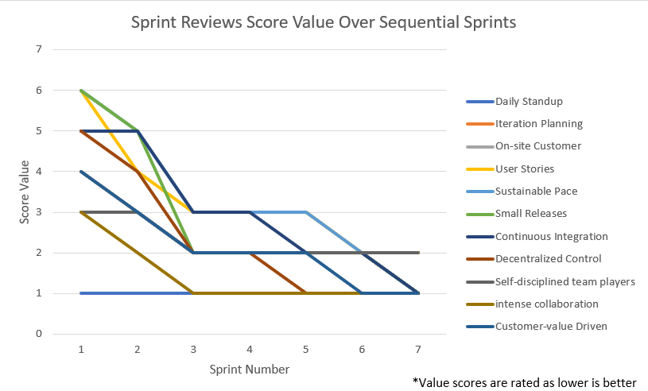

# Conclusion

We believe that by the end of the class we were able to follow and implement the principles of Agile. We learned how to make our board more visual and really break down the stories into chunks. We had very frequent feedback from each other and from the customer that we were able to then apply to the next sprint to continuously improve. Additionally, we figured out what “done” meant for us and how to decide when to move a story or feature to the done category. We used a lot of different tools and techniques to implement Scrum and we learned the process together through real world experience. The sprints allowed us to practice what we learned in the lectures and as we moved through them we were able to improve and create a smooth flow by the end of the process. Now we can take the skills we learned from this class and apply them throughout our graduate programs and future careers.

We would like to express our sincere gratitude to **Professor Shah, Mr. Hrcsko, Mr.Meyer** for their guidance, support, and mentorship throughout the completion of the project and course. Their expertise and knowledge have been instrumental in helping us understand the intricacies of agile methodologies and how they can be applied to solve real-world business problems.

# 

# Figures and Images

**Kanban Board**

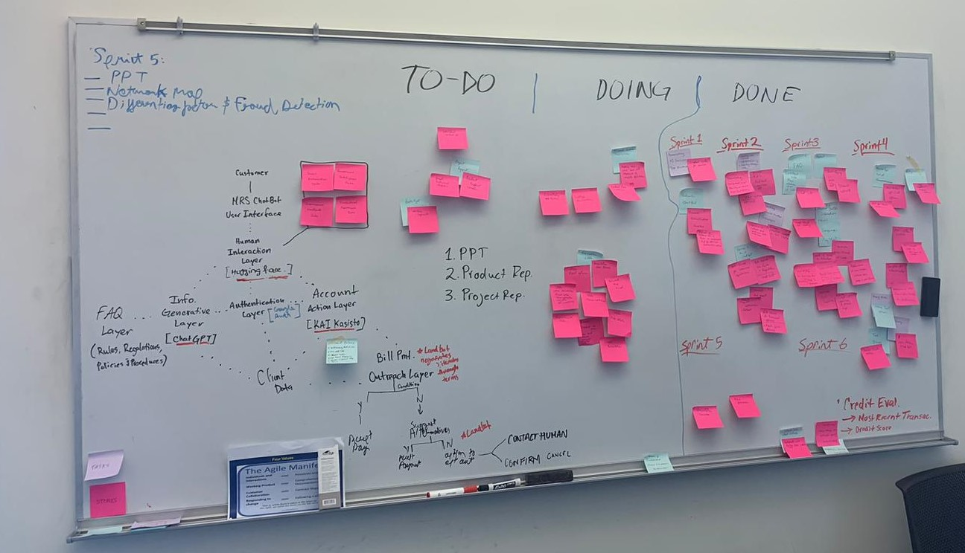

## Low-Level Chatbot Architecture

## 

**High-Level Chatbot Architecture**

